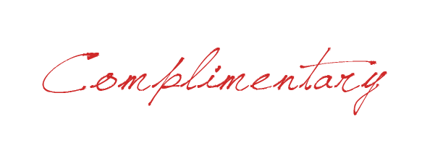

REGISTRATION FORM
for STUDENTS

This registration form gives access to the Thessaloniki Summit 2019,
November 14 & 15, 2019.
Please note, this registration form does not include the two official dinners.

PARTICIPANT INFORMATION
To register for the THESSALONIKI SUMMIT 2019, please fill in this form (in ENGLISH and in CAPITAL LETTERS) and return it to the Federation of Industries of Greece, 1, Morihovou sqr., 54625, Thessaloniki, GREECE, tel. +30 2310 539817, fax. +30 2310 541933, email: thessalonikisummit@sbe.org.gr

SURNAME
FIRST NAME
UNIVERSITY
Email:
Telephone:

